GOVERNOR’S PHYSICAL FITNESS AWARD
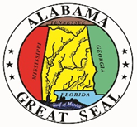
Presented to

on

for scoring in the high fitness zone in each test component of the
Alabama Physical Fitness Assessment

Sponsored by the Alabama State Department of Education, Alabama State Department of Public Health, and Alabama Governor’s Commission on Physical Fitness and Sports
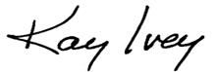
______________________________
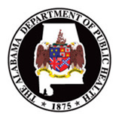
Governor of the State of Alabama
